

APPLYING FEDERATED LEARNING WITH SMART CONTRACTS IN HEALTHCARE

## PROJECT SUPERVISOR

Dr. Farrukh Shahid

## PROJECT CO-SUPERVISOR

Mr. Shahbaz Siddiqui

## PROJECT TEAM

Sarmad Jamal K191116

Khizer Jilani K191057

Mansoor Butt K191114

Submitted in partial fulfillment of the requirements for the degree of Bachelor of Science in Software Engineering.

FAST SCHOOL OF COMPUTING

NATIONAL UNIVERSITY OF COMPUTER AND EMERGING SCIENCES KARACHI CAMPUS

July 2023

|  |  |
| --- | --- |
| Project Supervisor | Dr. Farrukh Shahid |
| Project Team | Sarmad Jamal K19-1116  Khizer Jilani K19-1057  Mansoor butt K19-1114 |
| Submission Date | May 2, 2023 |

## Mr. Supervisor Name

**Supervisor**

## Mr. Co-Supervisor Name

**Co-Supervisor**

**Dr. Zulfiqar Ali Memon**

**Head of Department**

FAST SCHOOL OF COMPUTING

NATIONAL UNIVERSITY OF COMPUTER AND EMERGING SCIENCES KARACHI CAMPUS

# Acknowledgement

We would like to express our deep appreciation to our supervisor, Dr. Farrukh Shahid, whose invaluable support, constructive criticism, and unwavering encouragement were instrumental in the development and refinement of this project. His expert guidance and insights proved to be an invaluable asset, and we could not have completed this project without his guidance.

We also extend our sincere gratitude to our co Supervisor MR. Shahbaz Siddiqui, particularly for their guidance and mentorship throughout the project. Their expertise and support helped us navigate various challenges and develop an optimized, efficient solution that met our project's objectives.

Furthermore, we would like to acknowledge the financial and emotional support of our parents. Their unwavering belief in our abilities and moral support helped us remain focused and motivated throughout the project's duration.

In conclusion, we express our heartfelt appreciation to all those who contributed to this project's success, and we hope that this work will prove to be a valuable contribution to the academic community.

# Abstract

This FYP project aims to address the problem of the lack of medical data sharing in healthcare, which is a major obstacle in integrating artificial intelligence (AI) technology. The reason behind the data-sharing hurdle is that medical data is highly confidential, and hospitals are reluctant to share it due to privacy concerns. As a result, machine learning (ML) models cannot be trained, and progress in this field is stalled. To overcome this issue, this project proposes an alternative approach, which involves model sharing and federated learning. The proposed system consists of two entities, the Super user and hospitals. The Super user requests hospitals to participate in federated learning, and registered hospitals are granted access to global model files through IPFS hashes. These hashes are stored on the block chain via smart contracts. The technologies used in this project include Solidity for smart contract development, React.js for the frontend, and IPFS Piñata for hosting ML model files. This solution provides a viable and secure way to enable AI integration in healthcare while maintaining patient privacy.

Table of Contents

[List of Figure 6](#_bookmark0)

[List of Tables 7](#_bookmark1)

1 [Introduction 8](#_bookmark2)

1.1 [Project Scope 8](#_bookmark3)

1.2 [Project Objective 8](#_bookmark4)

2 [Requirements Analysis 10](#_bookmark5)

2.1 [Functional Requirements 10](#_bookmark6)

2.1.1 [Functional Hierarchy 10](#_bookmark7)

2.2 [Use Cases 11](#_bookmark9)

2.1 [Form Submission 11](#_bookmark11)

2.2 [Hospital/Super User Use Case 14](#_bookmark13)

2.3 [Non-functional Requirements 15](#_bookmark39)

2.3.1 [Performance Requirements 15](#_bookmark40)

2.3.2 [Safety Requirements 15](#_bookmark41)

2.3.3 [Security Requirements 15](#_bookmark42)

2.3.4 [User Documentation 15](#_bookmark43)

3 [Design Details 16](#_bookmark44)

3.1 [Design Extension, Interface & Data Management 16](#_bookmark45)

3.2 Design Strategy [16](#_bookmark46)

3.3 [ER Model 16](#_bookmark48)

3.4 [Design Extension, Interface & Data Management Dictionary 16](#_bookmark50)

3.5 [Application Design 17](#_bookmark55)

3.5.1 [Class Diagram 17](#_bookmark56)

3.5.2 [Sequence Diagram 17](#_bookmark58)

3.5.3 [State Diagram 21](#_bookmark68)

3.5.4 [Data Flow Diagram 24](#_bookmark70)

4 [Implementation Details 25](#_bookmark73)

4.1 [System Architecture 25](#_bookmark74)

4.2 [System Component Design 26](#_bookmark76)

4.3 [Software Architecture 26](#_bookmark78)

4.4 [Development Tools Used 27](#_bookmark80)

5 [Testing and Evaluation 27](#_bookmark81)

5.1 [Environmental Needs 27](#_bookmark82)

5.2 [Validation Testing 28](#_bookmark83)

5.2.1 [Testing Approach(s) 2](#_bookmark84)8

5.2.2 [Test Pass/Fail Criteria 28](#_bookmark85)

5.2.3 [Test Cases 29](#_bookmark86)

# List of Figure

Figure 1 Use Case Diagram 1 11

Figure 2 Use Case Diagram 2 13

Figure 3 Register Sequence Diagram 1 17

Figure 4 Login Sequence Diagram 2 18

Figure 5 Upload Model Sequence Diagram 3 19

Figure 6 Update Model Sequence Diagram 4 19

Figure 7 Delete Model Sequence Diagram 5 20

Figure 8 Login State Diagram 1 21

Figure 9 State Diagram 2 22

Figure 10 State Diagram 3 23

Figure 11 State Diagram 4 24

Figure 12 System Architecture 25

Figure 13 Layered Software Architecture 26

# List of Tables

[Table 1 Register User 11](file:///D:\FEDERATED%20LEARNING%20WITH%20SMART%20CONTRACTS%20IN%20HEALTHCARE.docx#_bookmark14)

[Table 2 Login 13](file:///D:\FEDERATED%20LEARNING%20WITH%20SMART%20CONTRACTS%20IN%20HEALTHCARE.docx#_bookmark14)

[Table 3 Test case 1 29](file:///D:\FEDERATED%20LEARNING%20WITH%20SMART%20CONTRACTS%20IN%20HEALTHCARE.docx#_bookmark87)

[Table 4 Test case 2 29](file:///D:\FEDERATED%20LEARNING%20WITH%20SMART%20CONTRACTS%20IN%20HEALTHCARE.docx#_bookmark88)

[Table 5 Test Case 3 29](file:///D:\FEDERATED%20LEARNING%20WITH%20SMART%20CONTRACTS%20IN%20HEALTHCARE.docx#_bookmark89)

[Table 6 Test Case 4 30](file:///D:\FEDERATED%20LEARNING%20WITH%20SMART%20CONTRACTS%20IN%20HEALTHCARE.docx#_bookmark90)

[Table 7 Test Case 5 30](file:///D:\FEDERATED%20LEARNING%20WITH%20SMART%20CONTRACTS%20IN%20HEALTHCARE.docx#_bookmark91)

[Table 8 Test Case 6 31](file:///D:\FEDERATED%20LEARNING%20WITH%20SMART%20CONTRACTS%20IN%20HEALTHCARE.docx#_bookmark92)

[Table 9 Test Case 7 31](file:///D:\FEDERATED%20LEARNING%20WITH%20SMART%20CONTRACTS%20IN%20HEALTHCARE.docx#_bookmark93)

[Table 10 Test Case 8 32](file:///D:\FEDERATED%20LEARNING%20WITH%20SMART%20CONTRACTS%20IN%20HEALTHCARE.docx#_bookmark94)

[Table 11 Test Case 9 32](file:///D:\FEDERATED%20LEARNING%20WITH%20SMART%20CONTRACTS%20IN%20HEALTHCARE.docx#_bookmark95)

[Table 12 Test Case 10 33](file:///D:\FEDERATED%20LEARNING%20WITH%20SMART%20CONTRACTS%20IN%20HEALTHCARE.docx#_bookmark96)

# **1** **Introduction**

Block chain is also used in the healthcare management system for effective maintenance of electronic health and medical records. The technology ensures security, privacy, and immutability. This work proposes a framework by integrating the block chain and Federated Deep Learning in order to provide a tailored recommendation system. Electronic medical records contain personal and confidential information that traditional storage methods must protect against cyberattacks and third-party authentication. To overcome this challenge, a method of distributed storage was proposed in this work. The focus of this work is also on making treatment recommendations to patients by comparing their medical records with historical data. This work is motivated by the limitations of existing work. The current study supports his EHR preservation, but the recommendation system is neither discussed nor incorporated, making it difficult to create a treatment recommendation system. Federated learning may therefore lead to more accurate treatment recommendations

# **1.1 Project Scope**

Primarily, the scope of our final year project is limited. We will be limiting our scope to the medical sectors where a patient data will be recorded on our system and by means of recording, we will be using that data only to train our machine learning model. We will be using the concept of federated Learning Through Federated learning; multiple organizations or institutions work together to solve a machine-learning problem under the coordination of a central server or service provide. Thus, a deep-learning model is maintained and improved upon within a central server. The model is trained by distributing itself to hospitals which allows these sites to keep their data localized. Data from each collaborator is never exchanged or transferred during training. Instead of bringing the data to the central server, as in conventional deep learning, the central server maintains a global shared model, which is disseminated to all institutions. Each entity subsequently maintains a separate model based on its own patients’ data. Thereafter, each center provides feedback to the server based on its individually trained model—either by its weight or the error gradient of the model. The central server aggregates the feedback from all participants, and based on predefined criteria, updates the global model. The predefined criteria allow the model to evaluate the quality of the feedback and therefore to only incorporate that which is value-adding. The feedback from centers with adverse or strange results can thus be ignored. This process forms one round of federated learning, and it is iterated until the global model is trained.

# **1.2 Not in Scope**

We will be only targeting one/two disease for the recommendation and it will be running on local environment not globally deployed. It will be on private block chain and only people who are connected will have the feasibility to connect to it

# **1.3 Problem Statement**

Recent advances in deep learning have shown many successful stories in smart healthcare applications with data-driven insight into improving clinical institutions’ quality of care. Excellent deep learning models are heavily data-driven. The more data trained, the more robust and more generalizable the performance of the deep learning model. However, pooling the medical data into centralized storage to train a robust deep learning model faces privacy, ownership, and strict regulation challenges. **Federated learning** resolves the previous challenges with a shared global deep learning model using a central aggregator server. At the same time, patient data remain with the local party, maintaining data anonymity and security.

This method provides decentralized machine learning model training with-out transmitting medical data through a coordinated central aggregate server. Medical institutions, working as client nodes, train their deep learning models locally and then periodically forward them to the aggregate server. The central server coordinates and aggregates the local models from each node to create a global model, then distributes the global model to all the other nodes. It is worth noting that the training data are kept private to each node and never transmitted during the training process. Only the model’s weight and parameters are transmitted, ensuring that medical data remain conﬁdential. For these reasons, FL mitigates many security concerns because it retains sensitive and private data while enabling multiple medical institutions to work together. FL holds an excellent promise in healthcare applications to improve medical services for both institutions and patients—for instance, predict autism spectrum disorder, mortality and intensive care unit (ICU) stay-time prediction.

## 1.4 Project Objectives

Our system implementation addresses the three major issues:

1. slow access to medical data
2. system interoperability

# **Requirement Analysis**

# **2.1 Functional Requirements**

## 2.1.1 Functional Hierarchy

## The super Admin and providers have a specific identity number that identifies their account. The account is accessed via a special account address of web3 provider such as meta mask and for another way of authentication we will use firebase to authenticate the data

As data will be generated from multiple organizations, data must be accessible and consistent at all times. The integrity of the data must not be compromised.

**Features**

We have Implemented a user-friendly application user interface using React Js technology. It provides an interactive and responsive UI with adequate performance. The navigation from one page to another is explicitly shown.

The project included the following features with respect to super admin and providers (Healthcare institutions).

Login: Login page for super Admin and provider

Signup: Signup page for provider

functionalities related to provider

View Form: Doctor can view patient available respective data

Fill form: Receptionist will submit the form of the patient

Request a particular doctor: Receptionist can request a particular doctor

Take part in training: provider will have a functionality to train its model

functionalities related to super Admin

Retrieve model: super Admin can retrieve hospital model and make it interact with the global model

Aggregation of model: super admin will aggregate the model based on the weights of the different models

## Use Cases

## 2.2.1 Form Submission

[Use Case Diagram]

*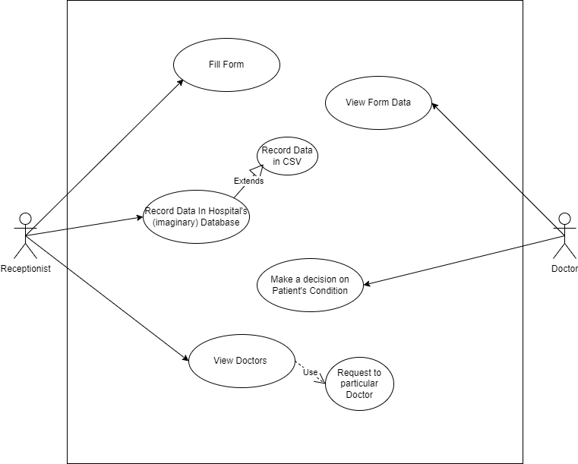*

***Figure 1***

|  |  |  |  |  |
| --- | --- | --- | --- | --- |
| **Form Submission** | | | | |
| **Use case Id:** | | 1 | | |
| **Actors:**  Receptionist, Doctor | | | | |
| **Feature:** Submission of form | | | | |
| **Pre-condition:** | | Receptionist must be logged in and have a list of doctors  Doctor should be authenticated and have a verified account given by the provider | | |
| **Scenarios** | | | | |
| **Step#** | **Action** | | | **Software Reaction** |
| **1.** | Fill the form of the patient | | | Fill input fields provided on the user interface and submit it |
| **2.** | Doctor will make a decision on the given form data and patient condition | | | A form view option will be visible to the doctor and he can view the patient data on the form and will make a decision accordingly for the treatment |
|  |  | | |  |
| **Alternate Scenarios:** | | | | |
| **None** | | | | |
| **Post Conditions** | | | | |
| **Step#** | **Description** | | | |
| **1** | A final decision for the patient treatment will be taken and if the patient agrees to take part in training aggregate weights will be updated on the global server | | | |
|  |  | | | |
|  |  | | | |
| **Use Case Cross referenced** | | | None | |

***Table 1***

## Hospital/Super user Use Case

*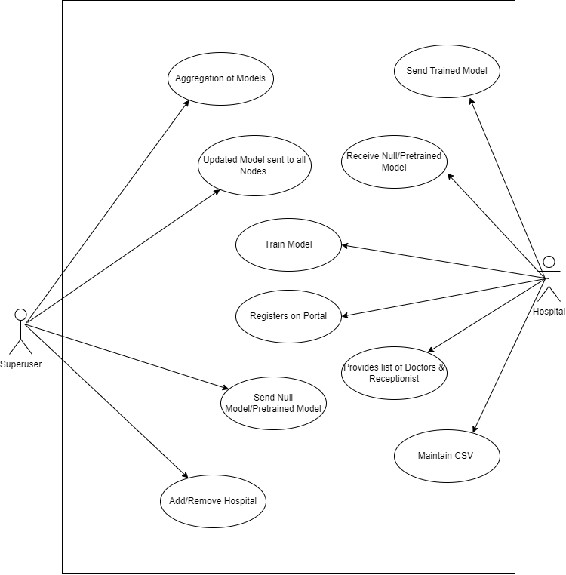*

***Figure 2***

[Use Case Description]

|  |  |  |  |  |
| --- | --- | --- | --- | --- |
| **Model training** | | | | |
| **Use case Id:** | | 2 | | |
| **Actors:**  Super User,Hospital | | | | |
| **Feature:** Training of Model | | | | |
| **Pre-condition:** | | SuperUser must be logged in and have access to global server model and have weights passed to it by the hospital | | |
| **Scenarios** | | | | |
| **Step#** | **Action** | | | **Software Reaction** |
| **1.** | Hospital will register itself on the portal | | | Hospital will get access to take part in training of model and interacting with our system |
| **2.** | Superuser can add or remove provider from the system | | | Hospitals with the penalty charges or the hospital which are sucessfully registered will act accordingly |
|  |  | | |  |
| **Alternate Scenarios:** | | | | |
| **None** | | | | |
| **Post Conditions** | | | | |
| **Step#** | **Description** | | | |
| **1** | Trained model on the recent data will be passed to the hospital and all the nodes will be updated | | | |
|  |  | | | |
|  |  | | | |
| **Use Case Cross referenced** | | | 1 | |

***Table 2***

# **Non-Functional Requirements**

## Performance Requirement

Average load time of the login page of the system must be less than 1.5 second.

NFR01-02 Average processing time taken by the system to complete a transaction/request

should be less than 10 seconds.

NFR01-03 System Mean Time to Failure should not be more than 60 seconds within 24

hours of use.

NFR01-04 Average system response time should not be greater than 5 seconds.

NFR01-05 System must successfully run on a client machine with 256 MB RAM or above

Average load time of the login page of the system must be less than 1.5 second.

NFR01-02 Average processing time taken by the system to complete a transaction/request

should be less than 10 seconds.

NFR01-03 System Mean Time to Failure should not be more than 60 seconds within 24

hours of use.

NFR01-04 Average system response time should not be greater than 5 seconds.

NFR01-05 System must successfully run on a client machine with 256 MB RAM or above

The System shall be based on web and has to be run from a web server. The system shall take initial load time depending on internet connection strength which also depends on the media from which the product is run. The performance shall depend upon hardware components of the client/customer

## Safety Requirement

The software is completely environmentally friendly and does not cause any safety violations. The web page will have a flexible font that can be zoomed so as to not over constrain the eyes.

## Security Requirement

### Data Transfer

* The system shall use secure sockets in all transactions that include any confidential customer information.
* The system shall automatically log out all customers after a period of inactivity.
* The system shall confirm all transactions with the customer’s web browser.
* The system shall not leave any cookies on the customer’s computer containing the user’s password.
* The system shall not leave any cookies on the customer’s computer containing any of the user’s confidential information.

### Data Storage

* The customer’s web browser shall never display a customer’s password. It shall always be echoed with special characters representing typed characters.
* The customer’s web browser shall never display a customer’s credit card number after retrieving from the database. It shall always be shown with just the last 4 digits of the credit card number.
* The system’s back-end servers shall never display a customer’s password. The customer’s password may be reset but never shown.
* The system’s back-end servers shall only be accessible to authenticated administrators.
* The system’s back-end databases shall be encrypted.

## User Documentation

The software is accompanied by the following materials for further help:

● Software Requirement Document

● Software Design Specification Document

# **Design Details**

# **3.1 Design Extension, Interface & Data Management**

## 3.1.1 Future System Extension or Enhancement

The system will be built using the latest edition of framework and incase a new update occurs in technology we must be ready. Stay updated by tracking orders with customized alerts and resolve issues proactively. Track real-time, Optimize routes and schedules and resource allocation in one centralized view.

## User Interface Paradigm

The user interface is very reliable and understandable to the user, the interface designed in such a way that mostly any expertise of people can easily learn and understand that what happens if I click this option, interface is very effective and efficient to increase the usability of users.

## Data Management

Main Data which are models will be stored on the IPFS and the relevant hashes of the model will be stored on smart contracts. Hospital will upload the model on web3 interface then store the model on the IPFS which will be use to apply federated leaning through aggregating of all these models.

Form typically collects the following data:

Patient Name

Fever

Blood Pressure

Heart Rate

Platelets

Blood Group

Weight

Age

ETC

# **Design Strategy**

## Database Design

**Not applicable (Database is being used to store data temporarily for authorization and registration purpose only, there are no other relations)**

## Application Design

## Sequence Diagram

#### 3.5.1.1<Sequence Diagram 1>

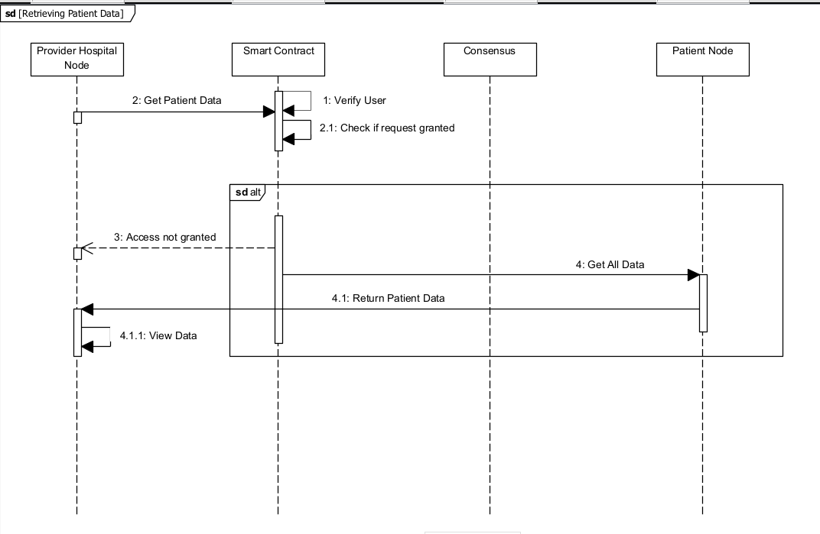

***Figure 3***

#### 3.5.1.2<Sequence Diagram 2>

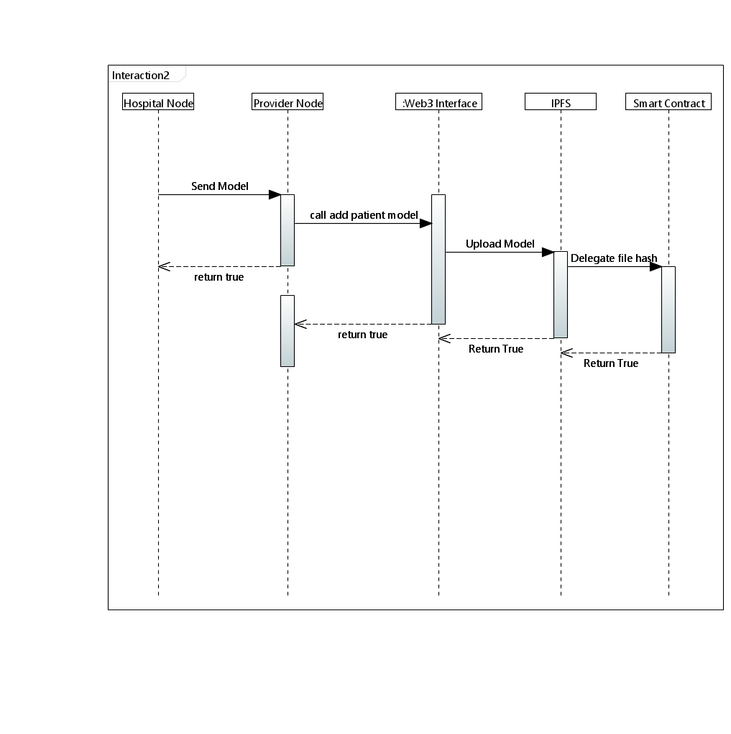

***Figure 4***

.

#### 3.5.1.3 <Sequence Diagram 3>

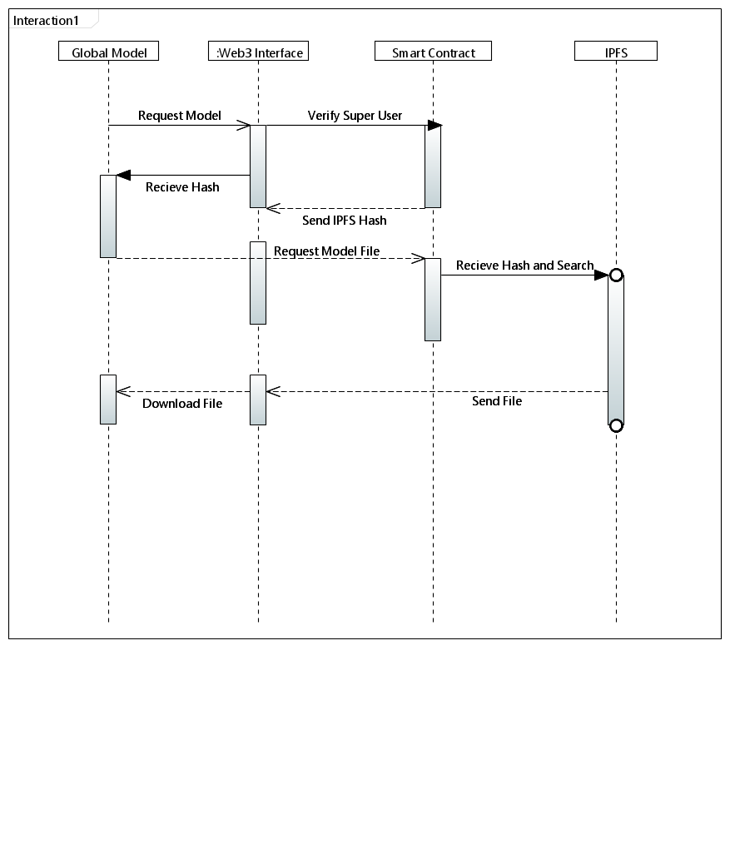

***Figure 5***

### 3.5.1.4<Sequence Diagram 4>

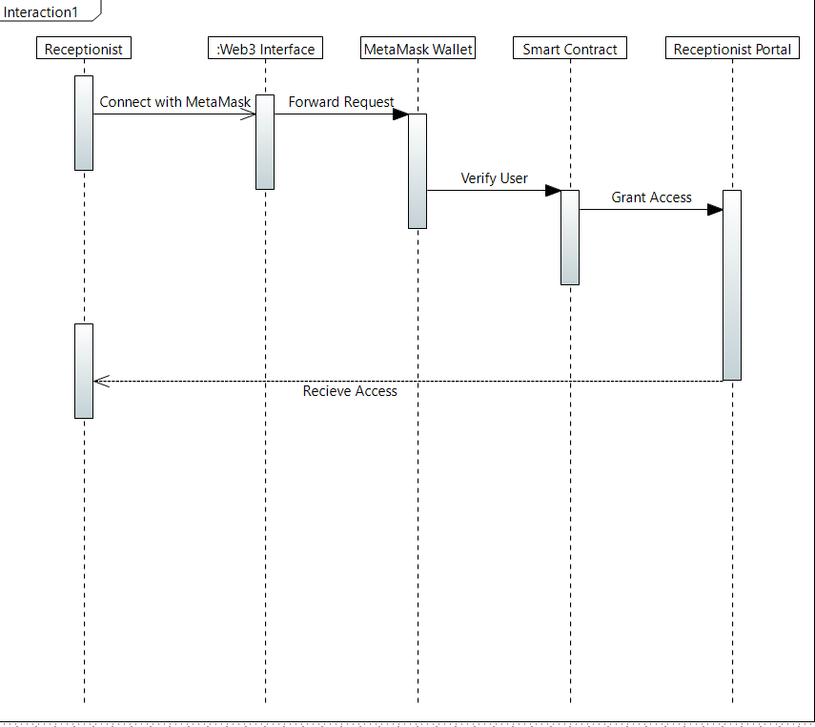

***Figure 6***

#### 3.5.1.5 <Sequence Diagram 5>

### Sequence_Diagram_1_Doctor_portal.drawio-1

## State Diagram

**3.5.2.1<State Diagram 1>**

**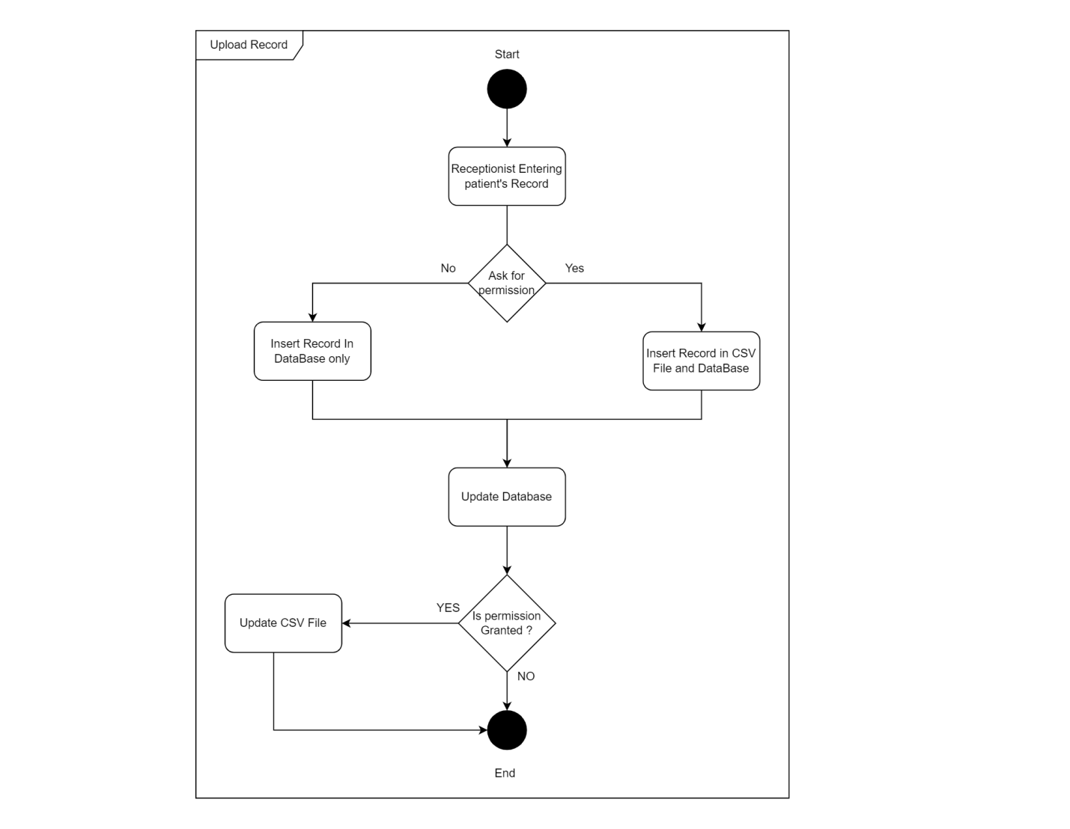**

***Figure 8***

**3.5.2.2<State Diagram 2>**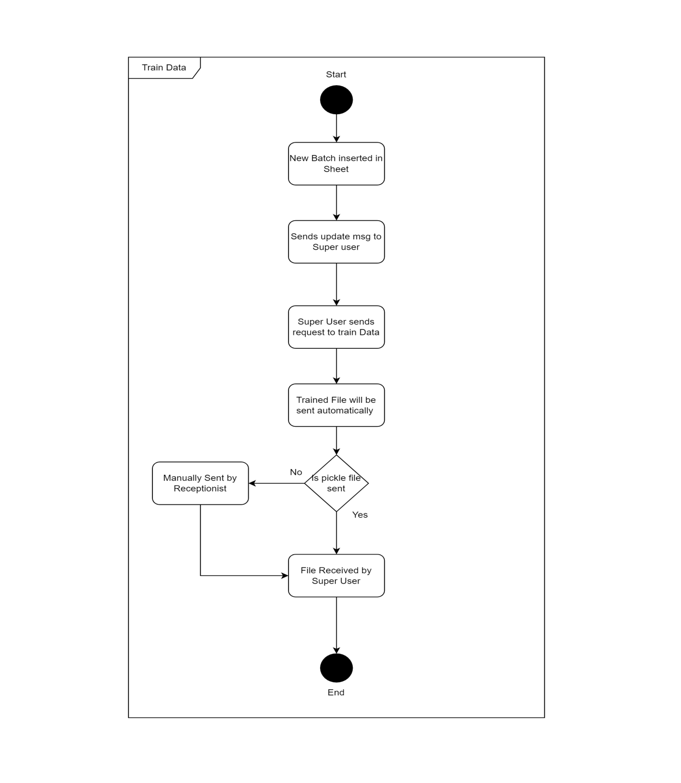

References

*[This section should provide a complete list of all documents referenced at specific point in time. Each document should be identified by title, report number (if applicable), date, and publishing organization. Specify the sources from which the references can be obtained (This section is like the bibliography in a published book)].*

**3.5.2.3<State Diagram 3>**

# state 3

# Appendices

*[Include supporting detail that would be too distracting to include in the main body of the document.]*

***Figure 10***

**3.5.2.4<State Diagram 4>**

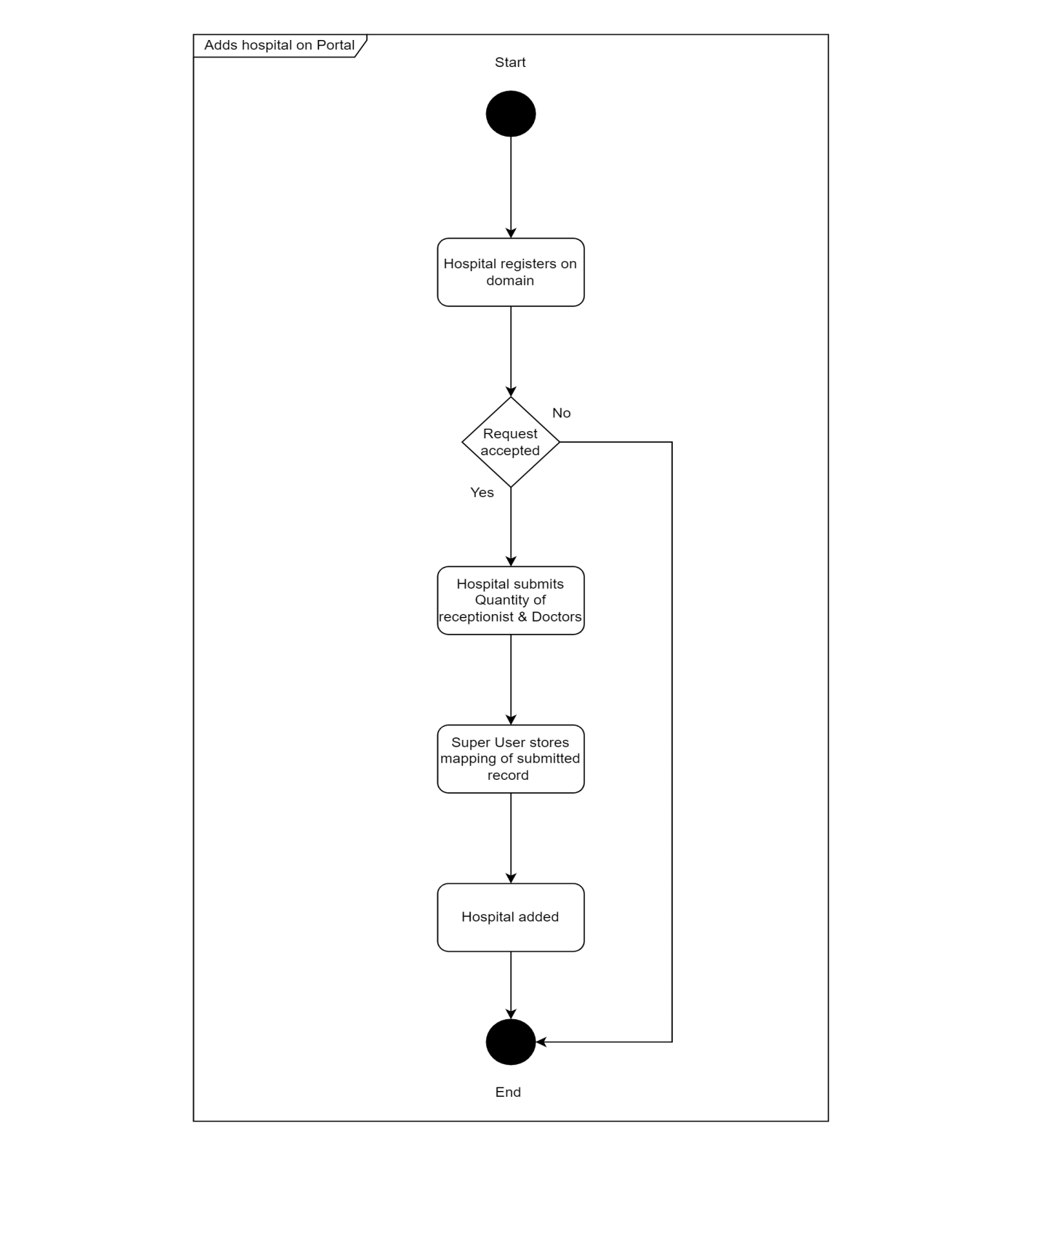

***Figure 11***

# **Implementation Details**

# **System Architecture**

Hospital can request the model from the Global server then download the model. After downloading the model, they will be training it on their own data. After the training is completed, the model will be sent back to the global server this process will be repeated by all the hospitals on the network who are taking part in this training after all the models are received by the global server it will then aggregate all these models through ensemble learning and a new model with combined intelligence of all the aggregated model will be formed This new model will be delegated back to all the hospital.

## System Level Architecture

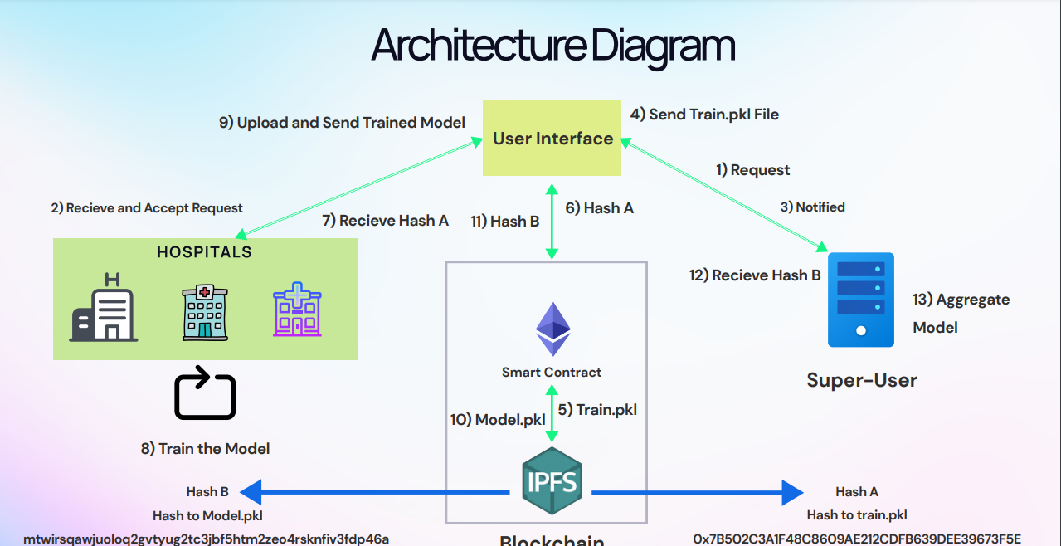

***Figure 12***

**High Level System Architecture**

## Software Architecture

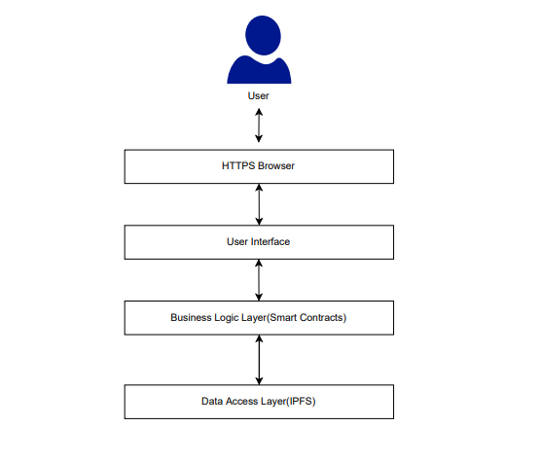

**Layered Software Architecture**

***Figure 13***

# **4.4 Development Tools Used**

The development tools and software technologies used are as follows:

* React JS
* Node JS
* Express JS
* Git version controlling
* PyCharm
* Visual Studio Code
* Postman
* Thunder Client
* Solidity
* Remix
* EtherJS
* Web3
* Hardhat
* MetaMask
* Ganache

# **5 Testing and Evaluation**

The purpose of this document is to provide a comprehensive outline of the validation and testing procedures necessary for ensuring the effectiveness and proper functionality of our project. The primary objective of this endeavor is to ascertain whether the project satisfies its requirements. In order to achieve this goal, three distinct types of testing will be conducted: unit testing, performance testing, and system testing. Through these rigorous testing procedures, the entire system will be thoroughly scrutinized to guarantee its efficient operation and robust performance. It is hoped that the results of these tests will provide valuable insights that will enable us to improve and optimize the project, thus enhancing its overall efficacy and value.

# **5.1 Environmental Needs**

Following are the hardware assumptions for using the system

* **I3** core processor or above
* **4 GB** RAM or above
* **256 GB** SSD space
* Keyboard and Mouse
* Internet Browser (any)
* English language supported only

# **5.2 Validation Testing**

# **5.2.1 Testing Approach(s)**

**Unit Testing:** The main objective is to test individual components of a system are tested in isolation to ensure that they are working properly. This helps to identify and fix any defects or bugs in the system's components before they are integrated.

**Integration Testing:** Testing all integrated modules to verify that the combined functionality after integration is in a workable state. The objective of this testing is to ensure that all the integrated modules are working properly and are producing the desired output.

**System Testing:** The entire system is tested as per the requirements. Overall requirement specifications and all the combined parts of a system are tested.

**Usability Testing:** The objective of this testing is to ensure that the system is easy to use, user-friendly, and meets the user's expectations. It involves testing the system's navigation, interface, functionality, and user experience to identify any usability issues and to provide recommendations for improvement.

**Performance Testing:** The objective of this testing is to ensure the system works under heavy traffic that includes large size video length processing.

# 5.2.2 Test Pass/Fail Criteria

If the application failed to generate results, provide errors or crashes then it is a failure else it is Pass.

### 5.2.3 Test Cases

|  |  |  |  |  |
| --- | --- | --- | --- | --- |
| **Test Case**: 01 | | | | |
| **Description**: Test login functionality | | | | |
| **No.** | **Steps** | **Expected Result** | **Actual Result** | **Pass/Fail** |
| 1 | User route to the login page | Display the page | Page displayed | Pass |
| 2 | User enters their credentials | Check for empty fields | Verify empty fields | Pass |
| 3 | User clicks on login button | Validate user login credentials | Validated credentials | Pass |
| 4 | User is redirected to respective page | Display the respective page | Displaying the respective user page | Pass |

***Table 3 Test case 1***

|  |  |  |  |  |
| --- | --- | --- | --- | --- |
| **Test Case**: 02 | | | | |
| **Description**: Test register user functionality | | | | |
| **No.** | **Steps** | **Expected Result** | **Actual Result** | **Pass/Fail** |
| 1 | Admin route to the register user page | Display the page | Page displayed | Pass |
| 2 | Admin enters the user credentials | Check for empty fields | Verify empty fields | Pass |
| 3 | Admin clicks on register button | Check credentials and register user in the database | Validated credentials and a new entry is added  in the database | Pass |

***Table 4 Test case 2***

|  |  |  |  |  |
| --- | --- | --- | --- | --- |
| **Test Case**: 03 | | | | |
| **Description**: Test Upload Model | | | | |
| **No.** | **Steps** | **Expected Result** | **Actual Result** | **Pass/Fail** |
| 1 | User route to the upload Model page | Display the page | Page displayed | Pass |
| 2 | User enters the Model name & JSON and pickle files | Check for empty fields | Verify empty fields | Pass |
| 3 | User clicks on submit button | Upload Model Files on IPFS & hash in the smart contract | Upload Model Files on IPFS & hash in the smart contract | Pass |

***Table 5 Test Case 3***

|  |  |  |  |  |
| --- | --- | --- | --- | --- |
| **Test Case**: 04 | | | | |
| **Description**: Test update Model | | | | |
| **No.** | **Steps** | **Expected Result** | **Actual Result** | **Pass/Fail** |
| 1 | User route to the update Model page | Display the page | Page displayed | Pass |
| 2 | User enters the Model name & JSON and pickle files | Check for empty fields | Verify empty fields | Pass |
| 3 | User clicks on update button | Update Model Files on IPFS & hash in the smart contract | Update Model Files on IPFS & hash in the smart contract | Pass |
| 4 | User selected model will be uploaded | New Version of Model Uploaded | New Version of Model Uploaded | Pass |

***Table 6 Test Case 4***

|  |  |  |  |  |
| --- | --- | --- | --- | --- |
| **Test Case**: 05 | | | | |
| **Description**: Test extract query functionality | | | | |
| **No.** | **Steps** | **Expected Result** | **Actual Result** | **Pass/Fail** |
| 1 | User route to the start person identification page | Display the page | Page displayed | Pass |
| 2 | User select the incident folder | Display all the incident folders | Display the incident folders | Pass |
| 3 | User clicks on next button | Redirect to extract query page | Display the page | Pass |
| 4 | User select the video from the dropdown | Display the selected video | Video is displayed | Pass |
| 5 | User clicks on the extract button | Display the current video frame and frame extractor | The current video frame and frame extractor is  displayed | Pass |
| 6 | User capture the query and clicks on capture button | Display the capture image on the UI and upload the  image on the server | Image is displayed and uploaded on the server | Pass |

***Table 7 Test Case 5***

|  |  |  |  |  |
| --- | --- | --- | --- | --- |
| **Test Case**: 06 | | | | |
| **Description**: Test start person identification functionality | | | | |
| **No.** | **Steps** | **Expected Result** | **Actual Result** | **Pass/Fail** |
| 1 | User clicks on the start person re- identification button | Display the page and start the  Process | Page displayed and process is executed | Pass |
| 2 | Copy all the videos of the selected incident on the flask server | Files are copied | Files are copied | Pass |
| 3 | Copy the query image on the flask  server | Copy the query  Image | Query image is  copied | Pass |
| 4 | Execute the AI model process | Process is executed | Process is executing | Pass |
| 5 | Display the log results via socket | Display the  Messages | Messages are  displayed | Pass |

***Table 8 Test Case 6***

|  |  |  |  |  |
| --- | --- | --- | --- | --- |
| **Test Case**: 07 | | | | |
| **Description**: Test multiprocessing frame extraction functionality | | | | |
| **No.** | **Steps** | **Expected Result** | **Actual Result** | **Pass/Fail** |
| 1 | User clicks on the start person re- identification button | Display the page and start the  Process | Page displayed and process is executed | Pass |
| 2 | Execute the AI model process | Process is executed | Process is executing | Pass |
| 3 | The multi-processing base frame extraction is executed | Execute frame extraction on spawned processes | The processes are spawned on which frame extraction is execute. Reduced  time duration. | Pass |
| 4 | Display the log results via socket | Display the messages | Messages are displayed | Pass |

***Table 9 Test Case 7***

|  |  |  |  |  |
| --- | --- | --- | --- | --- |
| **Test Case**: 08 | | | | |
| **Description**: Test multithreaded inferencing bounding box functionality | | | | |
| **No.** | **Steps** | **Expected Result** | **Actual Result** | **Pass/Fail** |
| 1 | Execute the Person Detection process | Process is executed | Process is executing | Pass |
| 2 | The multithreading inferencing bounding box and cropping is executed | Execute inferencing bounding box and cropping on  spawned threads | The threads are spawned on which frame extraction is execute. Reduced  time duration. | Pass |
| 3 | Display the log results via socket | Display the messages | Messages are displayed | Pass |

***Table 10 Test Case 8***

|  |  |  |  |  |
| --- | --- | --- | --- | --- |
| **Test Case**: 09 | | | | |
| **Description**: Test the resulted video | | | | |
| **No.** | **Steps** | **Expected Result** | **Actual Result** | **Pass/Fail** |
| 1 | Execute the person re- identification process | Process is executed | Process is executing and result is displayed  on UI | Pass |
| 2 | User clicks on the video | Display the video with the marked points in the video where query person is found.  Heatmap Graph must be present | Videos are displayed in which person is found and the marked points are available in the video timestamp.  Heatmap graph is displayed | Pass |

***Table 11 Test Case 9***

|  |  |  |  |  |
| --- | --- | --- | --- | --- |
| **Test Case**: 10 | | | | |
| **Description**: Test the generate report feature | | | | |
| **No.** | **Steps** | **Expected Result** | **Actual Result** | **Pass/Fail** |
| 1 | User clicks on the generate report button | Generate the report of the current executed person  re-identification process | Report is being generated | Pass |

***Table 12 Test Case 10***